A SELF-SERVICE AUTOMATED TARGETING PORTAL
An Example of Model as a Service

Don Kridel, University of Missouri-St. Louis, Department of Economics, One University Boulevard, St. Louis, MO 6312-4400 USA, (314)516-5553, kridel@umsl.edu
Dan Dolk, Naval Postgraduate School, Information Systems, Monterey, CA 93943, USA (831)656-2260, drdolk@nps.edu

ABSTRACT
Over the last several decades, there has been a dramatic shift in the US economy in the direction of service-based employment. This, in turn, has led to a heightened interest in “service research”. In particular, research into service provision and innovation is becoming progressively more important as automated service-provision via the web matures as a technology. We describe a web-based “targeting service” that uses advanced dynamic model building techniques to conduct intelligent profiling and modeling. This automated modeling approach is designed to cost-effectively assist businesses in their targeting activities—independent of the firm’s size and targeting needs. Service provision may be altered by client type (size). In particular, we describe how the service has been utilized to provide “smart leads” for small to medium business (SMB) direct marketing (DM) campaigns, for targeting of DM campaigns (both acquisition and “up-sell”), and direct sales-force targeting in larger firms. Empirical results suggest that the automated modeling approach provides superior “service” (in terms of cost and timing) compared to more traditional manual service provision. Further, this model as a service approach can be provided externally as a web-based service and/or internally to co-create value with SMB.

INTRODUCTION
Service science management and engineering (SSME) is an emerging research discipline which reflects the dramatic shift in the US economy from product-based manufacturing to service-based employment. There is a concomitant growing interest in the academic community (especially in IS and marketing) in the area of service sciences (see Rai and Sambamurthy, [16]; Communications of the ACM special issue on service science, e.g [3], [11], [12], and [13]; and HICSS Track on Decision Technologies and Service Science, [6]). Key concepts and conceptual frameworks for SSME include service-dominant logic (Vargo and Lusch, [17]), service systems (Spohrer et al, [15]), co-creation of value, and service innovation.

SSME, being a young discipline, is still searching for basic paradigms upon which to establish its theoretical groundwork. On the application side of SSME, there has been relatively little discussion of the linkage between decision support systems (DSS) in the form of analytical modeling and service science. We describe a model as service system that helps bridge this gap by providing an automated modeling capability for targeting.

From the service-providing firm’s perspective, it is increasingly important to “innovate in service provision”. Given the central importance of the Internet, much of this innovation is likely to be driven by the automation (or digitization) of services. Our model-driven service system can be used to replace and/or augment part of the current modeling (targeting) process. Targeting has unsurprisingly been shown to be effective in increasing response rates. As we show in the cases below, targeting through automated analytics significantly outperforms more traditional methods. This improved performance relates primarily to the ability to model at a much-lower geographic level. Further, our “model as a service” can be “internal” (provides targeting for in-house initiatives) or “external” (as a Web-based service sold to a firm’s clients to help them with targeting).

EXISTING SERVICE PROVISION
Targeting typically looks very different in different-sized firms; further, targeting means different things to different companies. Smaller firms generally target informally, while (some) larger firms dedicate significant resources to target. Targeting may be used to for acquisition (typically Direct Mail), up-sell, retention, etc. At the highest level, acquisition targeting is simply using information about “current” customers to “find” and/or predict the behavior of “would-be” customers.

For SMBs, targeting is typically reduced to guesswork as the firms are not large enough to have modelers or afford modeling services. Typically, the SMB (or the firm’s DM agent) will either
- purchase “dumb lists of names” through a count-and-order system (e.g., firm buys 100 names from a particular set of zip codes with a particular set of demographic characteristics), or
- purchase names from one of many providers of “specialty lists” (e.g., if target is expectant mothers, there are list providers that specialize in lists comprised of expectant mothers).

For larger firms, the options are larger. The firm can utilize count-and-order and specialty-list options as the SMB does, but also has additional options:
- employ modeling staff to develop the required targeting models,
- use consulting service to build necessary models.

Targeting services are generally provided on a manual basis—that is, models are developed by analysts; the models are used to score targets, and then “smart lists” are generated from those scores (rankings). Parts of the targeting process have begun to be automated, e.g., “dumb lists” and fulfillment (creative, printing, and mailing) are available via the web.

THE AUTOMATED SERVICE-PROVISION PROCESS
Kridel and Dolk [9] describe automated dynamic model-building techniques derived from research in the areas of active decision support and automatic model generation ([2], [4], [5]) to generate context-specific customer lists. The service provision is summarized in Figure 1. Figure 1 provides the basic workflow for an on-demand customer (typically an SMB); the same basic workflow is employed for larger clients. Larger clients interact through a richer (less simple) GUI and their data is “already loaded and matched”. However, from the service provision perspective, the essence of the automated targeting process is the same.

Figure 1 describes the work flow underlying the automated process at a relatively high-level. The process begins with customer list from a client. Depending on the how the service is provided, the customer list may come from a CRM (e.g., SalesForce.com or Kintera Sphere), a user-created view of

Figure 1: Basic Targeting Work Flow, On-demand Version
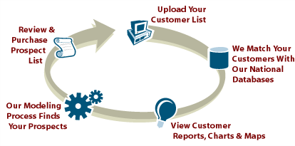
the customers of interest within the system itself (for enterprise portals) or uploaded directly by the user (typical for SMBs). The list is matched (and geo-coded) to a national database to obtain firmographics or demographics depending on whether the list is B2B or B2C. The modeling process driven by the modeling knowledge base develops a dynamic logistic regression model which is used for scoring. The ranked prospect list, along with profiles and maps, are available for downloading and/or on-line viewing. For some self-service portals, the user can also be “fulfilled” (e.g., select and mail desired DM piece to the provided list).

Figure 2 details the architecture of the work-flow process. The platform, described in Figure 2, can be implemented as a self-service portal, an enterprise “application”, or through web-services with existing applications (e.g., CRMs). In all three cases, the service is provided via the web. The knowledge base contains sets of “rules” embedded in templates that are used to develop the model(s). Along with rules of data-filling and transformations, the template contains “include” rules (which variables to test in model development) and “keep” rules (rules that decide whether the tested variables remain in the final model).

Examples of “include” rules are:
- ALWAYS: always test this variable in the model;
- PLI (Purchase likelihood index) based rules: e.g., 80< PLI > 120 or PLI > 125; the PLI is derived from the univariate analysis that is performed as part of the customer profile report;
- CELL SIZE: allows exclusion of small sample sizes by either counts or percentages;
- USE SPECIFIED VAR-LIST: generated from data-mining routines run elsewhere to select variables; or
- Some combination of the above (as multiple rules are allowed).

Examples of “keep” rules are:
- ALWAYS: always leave variable in the model
- Statistically-based rules: e.g., -2 > T-STAT > 2, or T-STAT > 1.65;
- Model (or iteration) based keep rules: e.g., likelihood ratio tests.

Figure 2: Automated Modeling Workflow
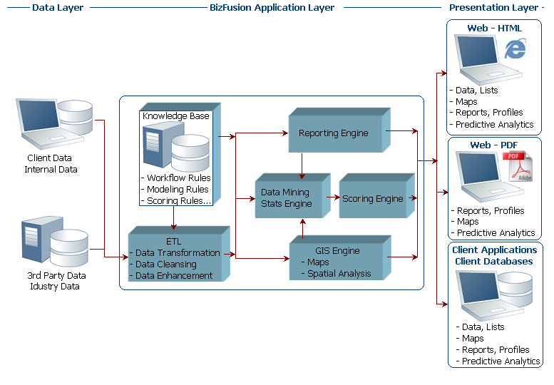

“Standard” modeling templates (e.g., retail acquisition) are available to all clients; custom templates may be built—either because of statistical “preferences” of the client or because the situation is in some unique (often when internal data from the client is being utilized in addition to data from the national database). For self-service clients, typically SMBs, the “default” templates are utilized since the necessary expertise to alter templates is likely not available (and lists are typically only name and address). Similarly, the modeling templates for enterprise clients are richer since these data typically include internal RFM (recency, frequency, and monetary value) variables. The modeling template “fully controls” the development of the dynamic model-building process.

EVALUATION
Evaluation of service systems under variability is also a critical research issue in SSME (Kannan and Proenca, [8]). To evaluate the customer targeting service system, two questions must be answered:
- Does the system provide service in the form of viable “clients”?
- Are the services provided useful in an economic sense?
While increases in the former would seem to imply economic utility, a more formal evaluation of (2) is provided.

The service system seems to be gaining traction in a wide variety of service-provision settings. Experian provides a private-labeled enterprise version of the automated-modeling platform (branded as Business Market Analyzer). They have recently added several new clients from retail, regional banking, and financial and marketing services. These firms utilize the service for internal targeting; in other words, targeting services to augment (or replace) current targeting practices for acquisition and retention. Further, Experian is scheduled to deploy a “portal version” for “external” targeting, which would allow upper range SMBs to mid-sized firms to utilize the targeting services. AT&T Yellow Pages is deploying an automated-modeling platform as part of a trial to provide targeting services to their SMB customers. AT&T has previously used the platform for “internal” targeting services as discussed below.

Kridel and Dolk [10] report on a case study that compares “dumb list via count-and-order selection” and “smart list obtained from automated modeling portal” for a SMB. The lift generated by the models is about 300% (7.8% vs. 1.4%). The immediate direct ROI is 120% (vs. -90% for the “dumb list”).

Edmiston and Kridel [7] describe in some detail the process that AT&T employed to determine whether to replace its manual modeling process with the automated process described here. The authors report that ROI exceeds 3000% (includes only the direct cost of the vendor’s contract—not COGS). During 2005 and 2006, response rates increased on average approximately 285%. Typically, this meant market conversion rates increased from the 0.25% - 0.5% range to the 0.75% - 1.5% range. Figure 3 recreated from [7] compares, by deciles, the actual response rates in a test market to the predicted response rate from the model.

Figure 3: Actual vs. Predicted Response Rates, Test Market

CONCLUSIONS
Spohrer et al [14] describe service systems as “collections of resources that can create value with other service systems through shared information.” Further, they suggest that “open” service systems
- are capable of improving the state of another system, and
- are capable of improving its own state by acquiring external resources.
The model as a service targeting workflow system we describe satisfies both aspects of this definition in the sense that the workflow interacts with other systems (both internal and external) to provide improved targeting which, in turn, leads to increased revenues and/or decreased costs. For example, in an enterprise setting the targeting workflow would augment and enhance existing BI and CRM systems to improve targeting models. As a result, customers receive fewer “nuisance contacts”, and more “offers of interest”, or both.

Although not a perfect substitute for full-time modeling, our model as a service does significantly reduce the amount of time required for a full-time analyst to target a market effectively in more detail than would otherwise be possible. It further shows the promise of shifting our view of decision technologies from commodities to services as suggested by (Bhargava et al [1]). This not only better positions modeling technologies with respect to service-based applications, but also holds the potential for extending the utility and relevance of analytical and computational models.

REFERENCES

[1] Bhargava, H. K., R. Krishnan, and R. Muller, "Decision Support on Demand: Emerging Electronic Markets for Decision Technologies" Decision Support Systems, Vol. 19, pp. 193-214, 1997.

[2] Castillo, D.G., D.R. Dolk, and D.J. Kridel, “GOST: An Active Modeling System for Costing and Planning NASA Space Programs”, Journal of Management Information Systems, Winter 1991-92, Vol. 8, No. 3, pp. 151-169.

[3] Dietrich, B., “Resource Planning for Business Services”, Communications of the ACM, July 2006, Vol. 49, No. 7, pp. 62-64.

[4] Dolk, D., and D. Kridel, “An Active Decision Support System for Econometrics”, Decision Support Systems, 7, 1991, pp. 315-328.

[5] Dolk, D., and D. Kridel, “Towards a Symbiotic Expert System for Econometric Modeling”, Current Research in Decision Support Technology, edited by R.W. Blanning and D.R. King, IEEE Computer Society Press, 1993, Chapter 7.

[6] Dolk, D. “Introduction to Decision Technologies and Service Sciences Track”, Proceedings of the 41st Hawaiian International Conference on System Sciences, Jan. 2008

[7] Edmiston, G. and D. Kridel, “Automated Modeling and Sales Targeting in the Real World: A Case Study for AT&T Advertising and Publishing”, presented at DMA*07, Chicago, IL, October 16-18, 2007.

[8] Kannan, P. and Proenca, J. “Design of Service Systems under Variability: Research Issues”, Proceedings of the 41st Hawaiian International Conference on System Sciences, Jan. 2008

[9] Kridel, D. and D. Dolk, “An On-line Marketing Consultant for Small and Medium Businesses”, Proceedings of the 32nd WDSI Conference, Lihue, HI, April 2003.

[10] Kridel, D. and D. Dolk, “Using Intelligent Profiling to Generate Smart Lists: An Empirical Test”, Proceedings of the 33rd WDSI Conference, Manzanilla, Mexico, April 2004.

[11] Maglio, P., S. Srinivasan, J. Kreulen, and J. Spohrer, “Service Systems,, Service Scientists, SSME, and Innovation”, Communications of the ACM, July 2006, Vol. 49, No. 7, pp. 81-85.

[12] Rust, R and C. Miu “What Academic Research Tells Us about Service”, Communications of the ACM, July 2006, Vol. 49, No. 7, pp. 49-54.

[13] Spohrer,J and D. Riiecken, “Services Science”, Communications of the ACM, July 2006, Vol. 49, No. 7, pp. 31-34.

[14] Spohrer, J, P. Maglio, J. Bailey, and D. Gruhl, “Towards A Science of Service Systems”, Computer, Jan. 2007.

[15] Spohrer, J, S. Vargo, N. Caswell, and P. Maglio, “The Service System is the Basic Abstraction for Service Science”, Proceedings of the 41st Hawaiian International Conference on System Sciences, Jan. 2008, pp. 1-10.

[16] Rai, A, and V. Sambamurthy, “Editorial Notes—The Growth of Interest in Services Management: Opportunities for Information Systems Scholars”, Information Systems Research, December 2006, Vol. 17, No. 4, pp. 327-331.

[17] Vargo, S. L. and Lusch, R. F. Evolving to a new dominant logic for marketing. Journal of Marketing, 68, 1, 2004, 1-17.

The modeling process for other types of targeting (e.g., retention or up-sell) follows a similar workflow.
Kridel and Dolk [9] provide examples of system artifacts and a simplified version of a modeling template (in flow-chart form).
It is worth noting that the modeling profile was used for the “dumb” selects. As a result, the “dumb” list is likely better than it would have been had the business owner simply had to guess at the appropriate selects.
After evaluating several vendors, AT&T selected CopperKey as its vendor of choice for automated modeling in December 2004.
Lift is calculated as: (Model Response – Base Response) / Base Response. Generally, the top-four deciles were used for the targeted lists; non-matched or random selections were used for base response rates.

