A PEDAGOGICAL FRAMEWORK FOR INTRODUCING A SECOND-LIFE EDUCATIONAL CAMPUS

Tod Sedbrook, Monfort College of Business, University of Northern Colorado, Greeley, CO 80639, 970-351-1337, tod.sedbrook@unco.edu
Vish Iyer, Monfort College of Business, University of Northern Colorado, Greeley, CO 80639, 970-351-2348, vish.iyer@unco.edu

ABSTRACT

We believe that Internet-based virtual worlds represent a new opportunity to enhance instruction and supplement student learning in higher education. Traditional commercial and open-source university course management systems such as Blackboard and Moodle agree and are merging their offerings to connect and interact within 3D virtual worlds. Hundreds of universities are exploring SL as an educational venue. Universities are using SL for distance learning, public outreach, writing labs, live modeling of business practices, connecting with professional, and exploring ethical issues. Conceptual models of web site evolution identify a pre-experimentation stage followed by the development of increasingly sophisticated facilities to satisfy stakeholder requirements and culminating with successful alignment web functionality and organizational objectives. Lessons learned from the web site development include the need to clearly define the benefits of offerings and introducing a formalized architecture for guiding the development of an on-line presence. Toward this end we are developing and investigating an architectural and governance framework to help higher educational institutions apply SL to sustain and extend their educational mission.

INTRODUCTION

Second life (SL) is a wild technology that promises to extend currently used instructional technology into realistic 3D immersive worlds [1]. We are investigating SL’s virtual 3D environment to help support student learning, supplement class room activities and encourage new ways of interaction among faculty and students. The future of the web is forming around virtual 3D worlds such as SL. Forecasters predict that "more than 80% of the Global 1000 will have a presence in at least one virtual world by year-end 2011[2]. Hundreds of companies are extending their business presence into SL including Accenture, Adidas, AMD, Dell, IBM, Intel, Major League Baseball, Sony, Sears and many others. Companies are investing in SL for product promotion, testing and design of new products and connecting employees scattered around the globe [3].
The SL Linden-dollar economy represents 15 million residents that participate in 19 million market transactions representing transactions of over $1.5 million per month. This economy has its own currency and stock exchange, where virtual stock and monetary prices are driven by forces of supply and demand. SL speculators include real-estate developers as well as banks and other financial lenders. A wide array of large and small SL business enterprises offers services and digital products including graphical artwork, music, books and entertainments.
We believe that Internet-based virtual worlds represent a new opportunity to enhance instruction and supplement student learning in higher education. Traditional commercial and open-source university course management systems such as Blackboard and Moodle agree and are merging their offerings to connect and interact within 3D virtual worlds [4]. Hundreds of universities are exploring SL as an educational venue. Universities are using SL for distance learning, public outreach, writing labs, live modeling of business practices, connecting with professional, and exploring ethical issues [5] [6].
Higher educational institutions are increasingly taking advantage of SL to complement on-line offerings, explore new approaches to internet commerce and study virtual world designs for distance education, nursing and heath education, business and visual arts [7] [8]. The evolution of an organization’s SL presence can benefit from key lessons learned from the studies of the past decade’s evolution of organization’s web presence. Lessons learned from the web site development include the need to clearly define the benefits of offerings and introducing a formalized architecture for guiding the development of an on-line presence [9]. Toward this end we are developing and investigating an architectural and governance framework to help higher educational institutions apply SL to sustain and extend their educational mission.
This research applies the design science approach to explore a framework for the development of SL facilities and evaluate its application within a case study context [10]. We explore SL development by 1) formulating a architecture for conceptually relate SL’s tools to learning pedagogies 2) identifying and guiding cross-campus stakeholders including student, faculty and administration partners and 3) applying the architecture within an iterative development methodology to construct a SL campus. Our approach is typical of design science research which investigates a prescriptive solution within a specific context. The goal is to create model architecture to identify activities required to introduce SL to a university community. We then apply the architecture to guide the initial construction of our university’s campus and evaluate its effectiveness in coordinating and guiding development of pedagogical applications within SL.
.
Figure One. Second Life’s Integrated Pedagogical Framework
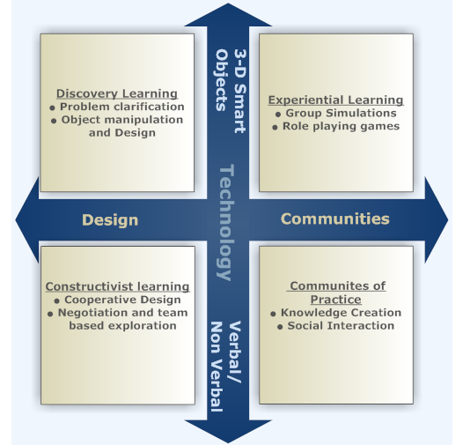

AN ARCHITECTURAL FRAMEWORK FOR SECOND LIFE PEDAGOGY

An integrative architectural framework is needed to support development of complex software systems. An architectural framework’s can help define objectives, organize component tools, and enhance stakeholder coordination, support testing and evaluations. Architecture provides a coherent and consistent governance framework for incremental changing and continually improving a software system [11]. Figure-1 above, summarizes our SL architectural framework. The framework is based on conceptualizing student interactions and classifying SL technologies through the theoretical lens of integrated learning. Integrated learning theory stresses the systematic and holistic integration of teaching environments and supporting technologies. Our primary goal in applying the integrated learning concept into SL architectural framework is to develop a multidisciplinary learning environment for our students which will amalgamate business theories to business practices and embed critical thinking and problem solving skills in our students.

The framework integrates of SL technologies within dimensions of design and community based learning theories. We build on the work of [12] to define intersections of SL‘s technologies and four standard learning theories The following classifies design can community pedagogies according to SL’s technology tools of smart objection and enhanced communication

REFERENCES

[1] Booch, G. The Economics of Architecture-First, IEEE Software. 2007, 24(5):18.
[2] Chu, S., Leung, L.C. et.al. Evolution of e-commerce Websites: A Conceptual Framework and a Longitudinal Study, Information & Management, 2007, 44(2), 154-164.
[3] Gartner Research, 2007, available at www.gartner.com/it/page.jsp?id=503861.
[4] Gollub, R. Second Life and Education, Crossroads, 2007, (14), 1-8.
[5] Hemp, P. Getting Real About Virtual Worlds, Harvard Business Review, 2008, 86(10), 27-28.
[6] Jennings, N., Collins, C. Virtual or Virtually U: Educational Institutions in Second Life, International Journal of Social Sciences, 2007, 2(3), 180-187.
[7] Kebritchi, M., Hirumi, A.C. Examining the Pedagogical Foundations of Modern Educational Computer Games, Computers & Education, 2008, 51(4), 1729-1743.
[8] Linden Research, Second Life, Retrieved September 2008 from http://lindenlab.com/
[9] McArthur, V. Real Ethics in a Virtual World, CHI ’08 Extended Abstracts on Human Factors in Computing Systems, 2008, Florence, Italy.
[10] Peffers, K.T., Tuunanan, et al. A Design Science Research Methodology for Information Systems Research, Journal of Management Information Systems, 2008, 24(3), 45-77.
[11] Ritzema, T. Harris, B. The Use of Second Life for Distance Education, J. Comput. Small Coll., 2008, 23(6), 110-116.
[12] Sloodle Learning Systems (2008). "Learning Systems for a Virtual Environment." from http://www.sloodle.org/moodle/

